**How investigator mobile app works**

Control one dispatchs request to investigator.

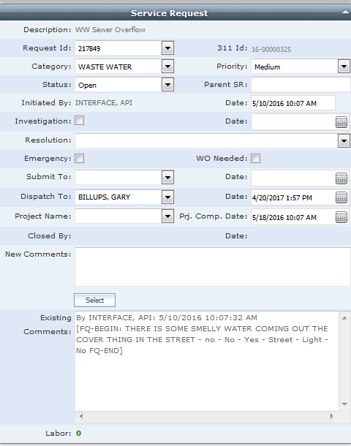

Investigator will log in his mobile app on iPad.

Log in credentials will be the same as your Cityworks.

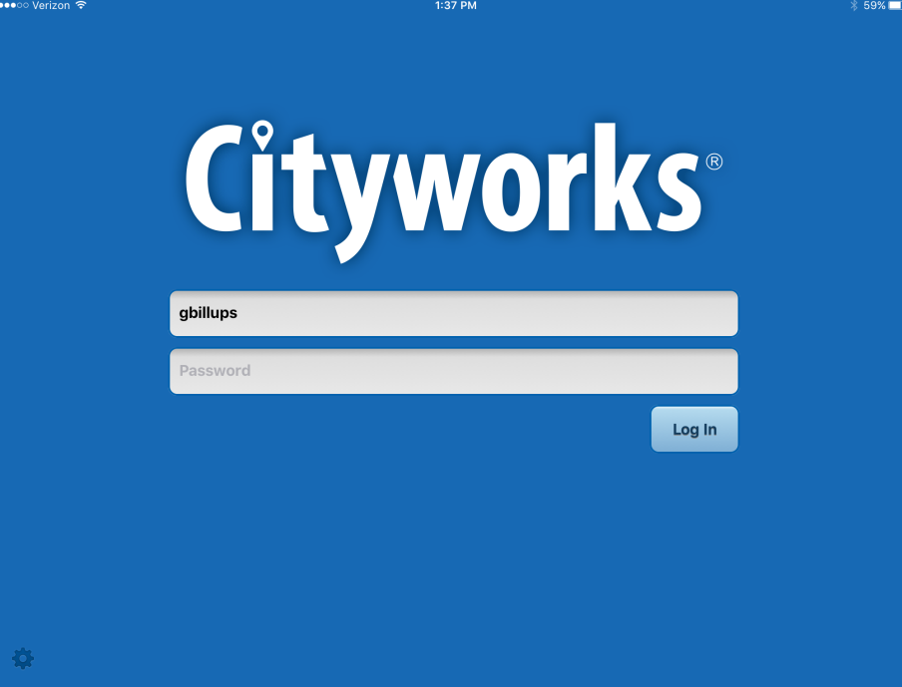

Investigator will see screen below, if investigator stays logged on for entire day they need to refresh screen by using

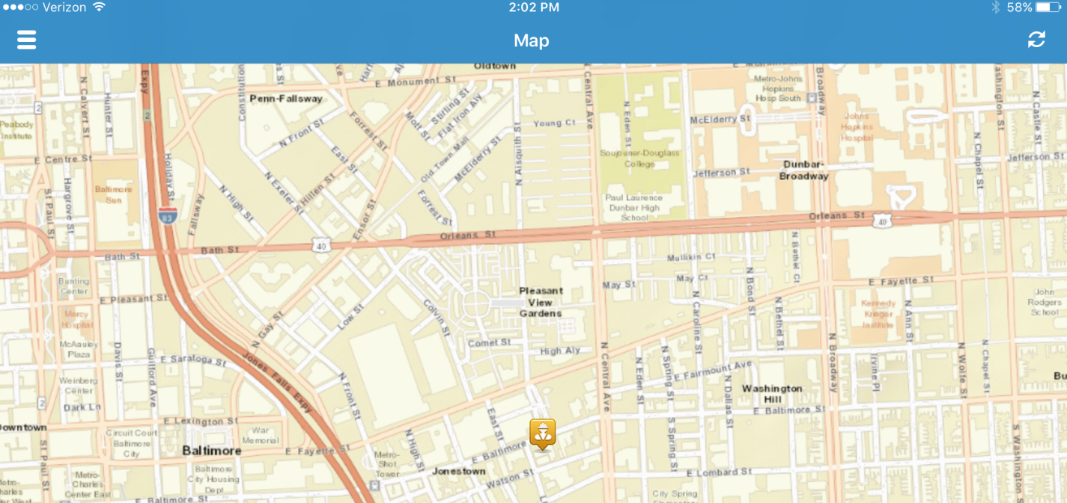

Once investigator click on icon, Type of Request and Request # will show up.

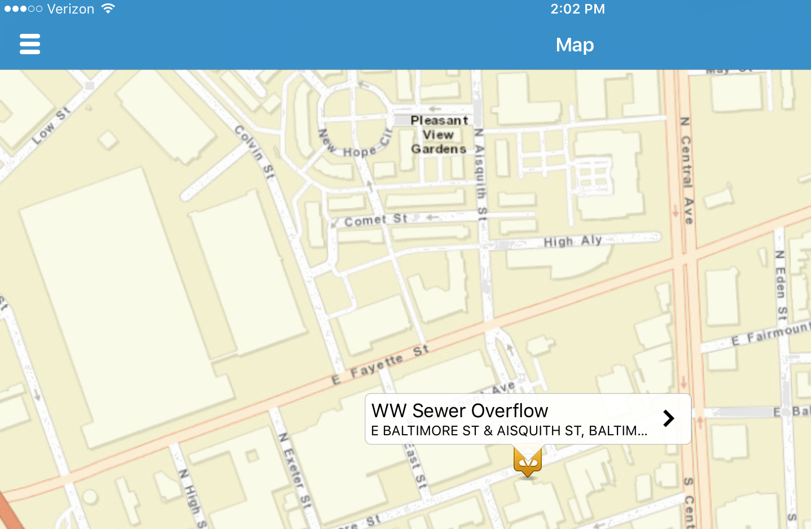

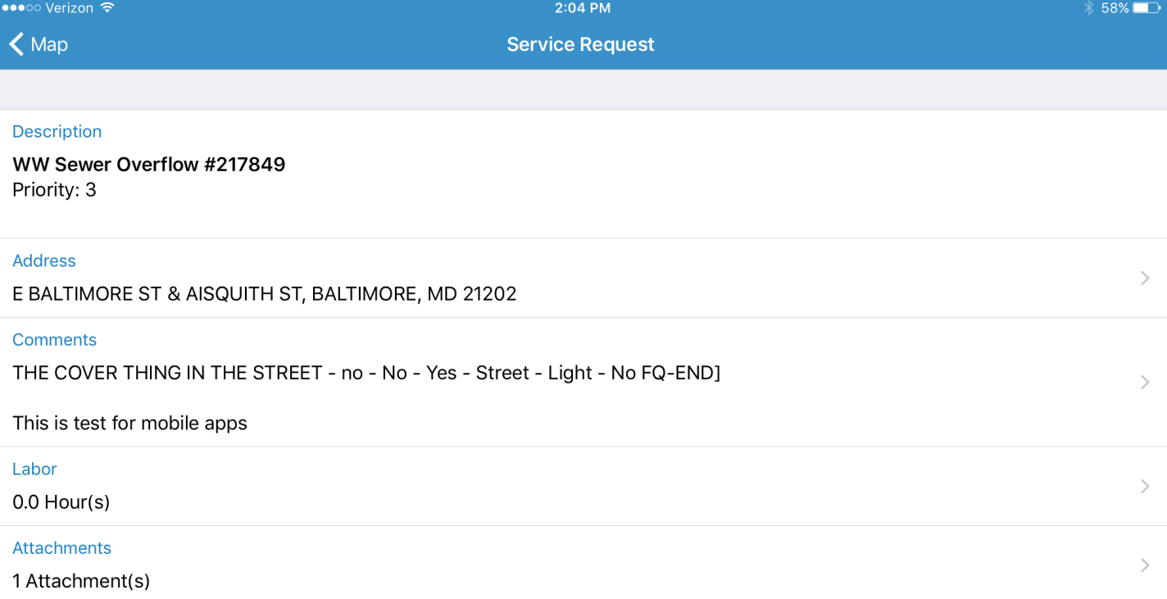Click on “>” to see more detail form of Request.

Final Comments added to SR and Picture is also attached to SR

Finally, slide button to complete request.

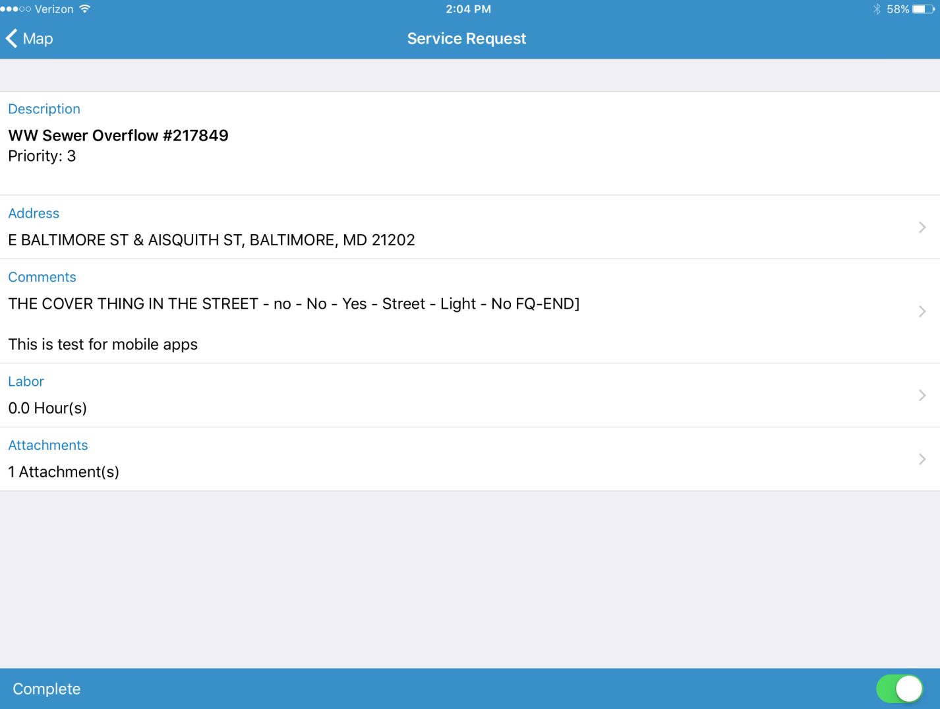

Click on Map to go back to map

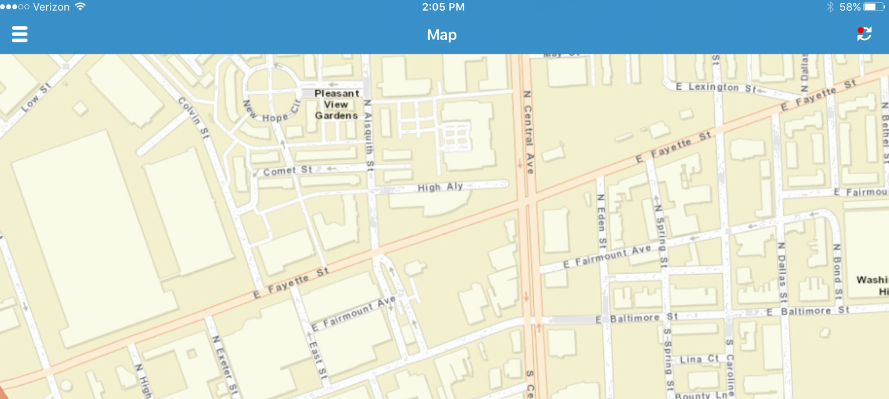

 Please note there is Red dot on your refresh icon. It indicates that changes made on the request are not synchronized with the server. Once the Investigator clicks on the icon it saves changes to Cityworks and the red dot should disappear.

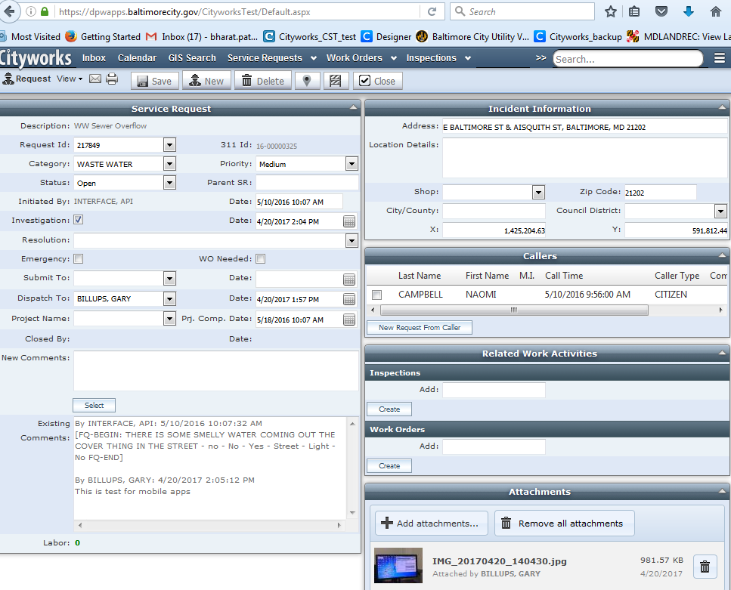

At this point the Investigator needs to confirm with control one that changes made are updated in Cityworks. Also ask for referral if needed.

Control one will make appropriate changes to status and if more work needs to be done, the appropriate link work order should be created.

This app will help the investigator to enter final comments of his investigation and also allow him to take pictures and attach it much easily.

Nothing else changes from old way of working with Request.